**3rd INTER-MEDICAL SCHOOL PHYSIOLOGY QUIZ**

*26-27th of May, 2023, Cluj-Napoca, Romania*

Physiology Department of "Iuliu Hațieganu" University of Medicine and Pharmacy Cluj-Napoca, organized the *1st and the 2nd Romanian Edition of the Inter-Medical School Physiology Quiz (2018, 2019)d*, a contest whose origins are attributed to Prof. Dr. Cheng Hwee Ming from the University of Malaya, Kuala Lumpur, Malaysia. Each time, the event took place in "Iuliu Hațieganu" Auditorium and it brought together a number of 24 teams of medical students from several Romanian Medical Universities, and some from abroad, thus comprising a total of 110 participants per edition. We can highlight the fact that this event was also a premiere due to the involvement of English section medical students from Arad, Cluj-Napoca, Craiova and Oradea Medicine Universities.

The Quiz was named after the distinguished Romanian Physiologist, Professor Mircea Dorofteiu, remarkable scientist of Cluj-Napoca Physiology, perfect teacher, exceptional researcher, trainer for numerous student generations, and a real model for all of us.

Professor Cheng is a distinguished Physiologist, recognised in entire world as a specialist in innovative approach to Physiology teaching and learning techniques. In Malaysia, this type of contest was organized for the first time in 2003, with 7 participant teams from Malaysia Universities. The enthusiasm of the students that participated to the competition, the contest impact on the Physiology teaching, but especially the implication and the unique vision of Professor Cheng, led to a progressive increase, year by year, of the interest for this quiz. The last edition of the Inter-Medical School Physiology Quiz brought together 460 students from 24 countries, organized in 104 teams, with 120 physiology lecturers. Over the years, Professor Cheng was invited to participate in coordination of this type of contest in different countries of Asia, but also in United States and Australia.

Romania is the first country from Europe that organized this competition.

Professor Simona Clichici, Chief of Physiology Discipline, and Professor Adriana Filip organized the two editions of the Romanian contest, with the help of the University and of the dedicated students in physiology.

Each time, Professor Cheng honoured us with his presence and coordinated the entire competition.

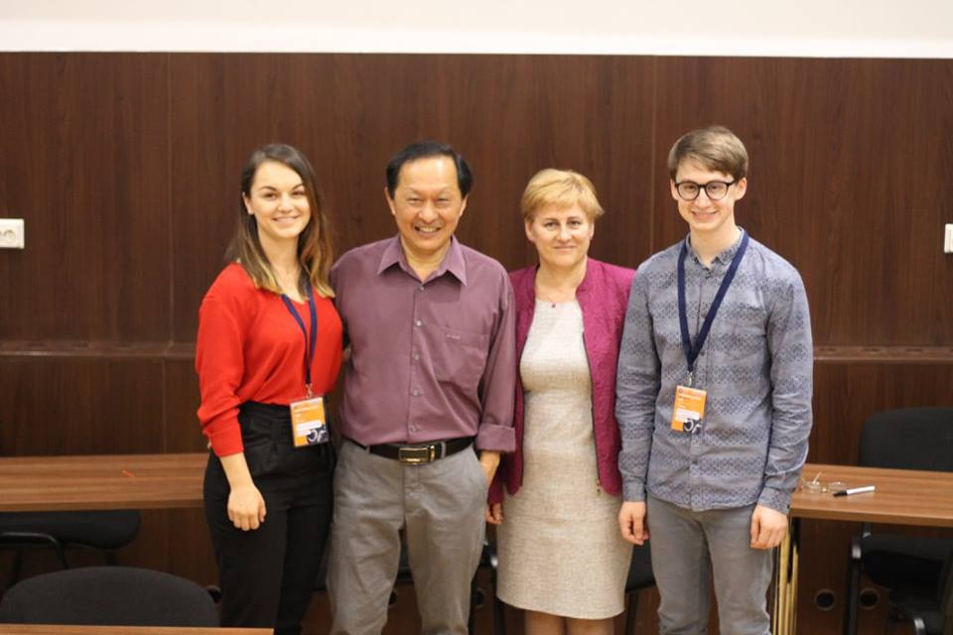

The Romanian quiz was based on the original version with adaptation to the smaller number of participants we had. Professor Cheng asked the questions that were particularly focused on Respiration, Excretion, Cardiovascular System, Hormones and Neuronal Physiology. The teams had 30 seconds to give the answers. With the chronometer started and with the public in front of them, the students had to prove their ability to focus, to work together and to write the best response they had.

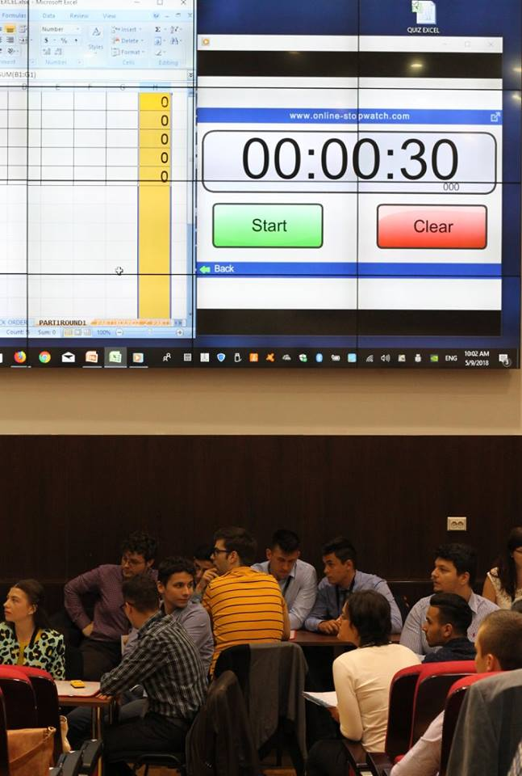

Our quiz was a real multicultural event and a moment of networking and friendship.

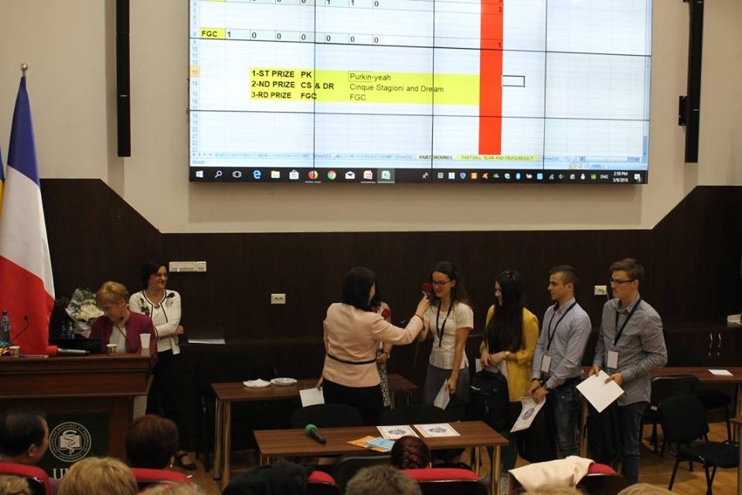

The event was a great success, being dynamic and attractive for the competing students, the University staff and other colleagues who supported the teams and followed the contest evolution till its end.

One of the participants sent us his feelings and some remarks regarding the event: "The competition was very engaging and, most important, it put our brains to work. The questions were wisely chosen and I really liked the fact that if there it was a misunderstanding regarding the answer, Professor explained it. Overall, I felt the competition as a great experience that helped me revise my physiology, understanding some physiological conditions even better now and, not to mention, making new friends. I am looking forward to the next edition!”

Professor Adriana Filip said that a great merit of this competition was the bringing together of the medical students from all over the country, students who spoke a common physiology language, and who demonstrated the great implications that physiology knowledge has in medical practice. They had the opportunity of sharing their knowledge and feelings regarding the medicine and the competition, and they had established long-lasting friendships.

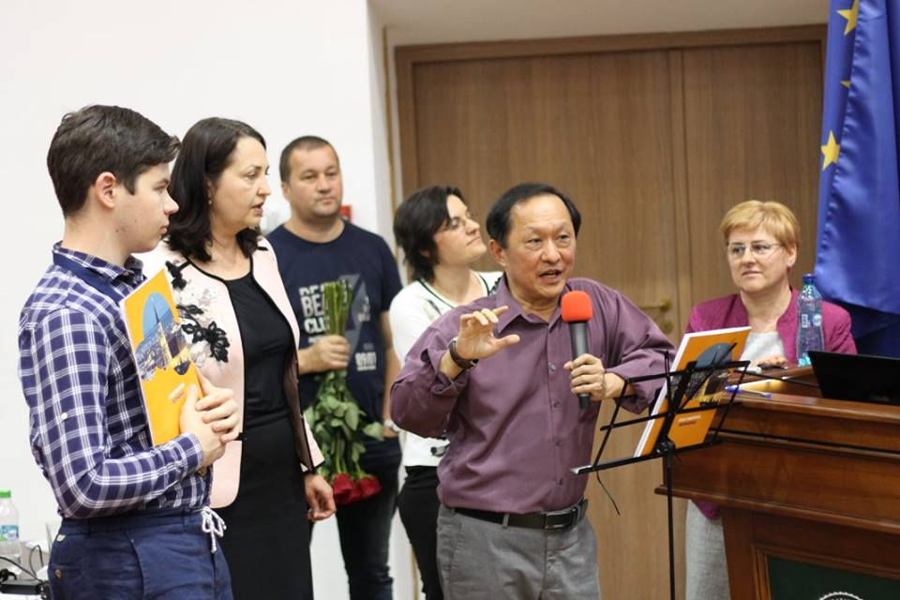

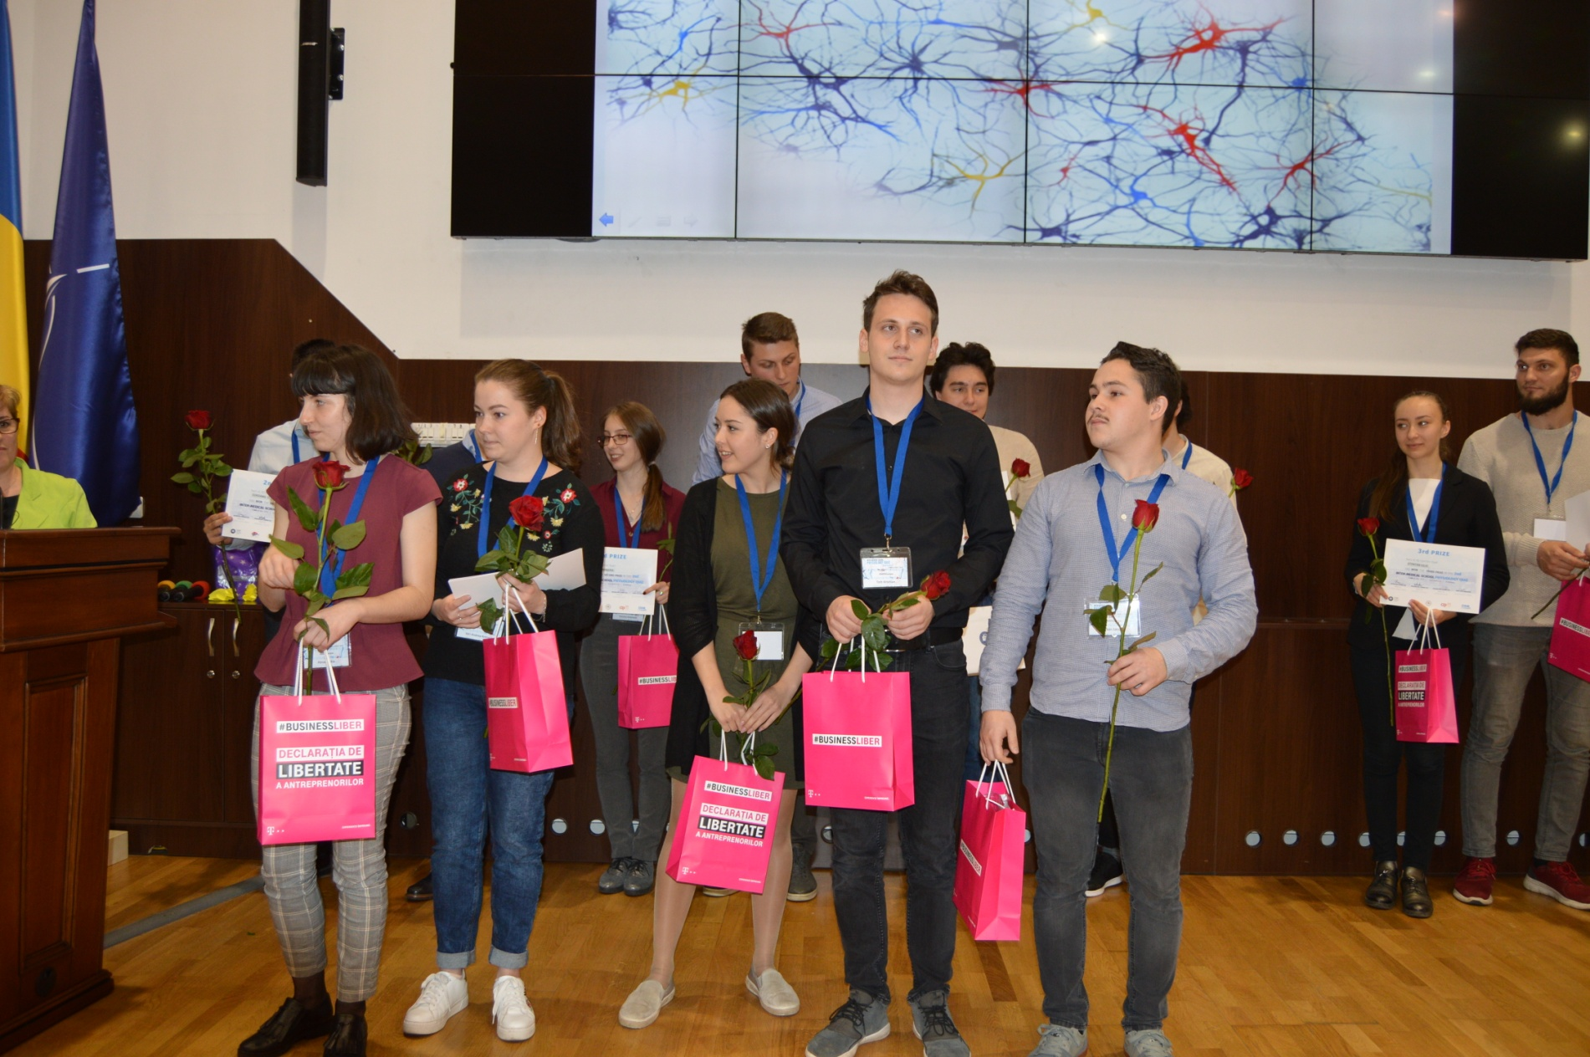

This year we can organize the 3rd edition of the *Romanian Inter-Medical School Physiology Quiz* and Professor Cheng accepted to come to Cluj-Napoca and to be, once again, part of this competition.

We would be very honoured to have students from all over the world at UMF Cluj-Napoca to take part in this vibrant contest

We invite you all to the next edition of this contest, in Cluj-Napoca, on 26-27*th of May 2023*!